Reader Hire Platform Overview

Contents

1. Main Requirement. 2

1) Frontend iPhone app with swift 2

2) Backend Web API & Database 2

2. Platform Infrastructure 3

3. Microservice with AWS 4

1) Upload and download recording result to/from S3 bucket. 4

4. Conferencing Protocol. 4

# 1. Main Requirement.

## 1) Frontend iPhone app with swift

- Management profile of Actor and Reader.

- Booking Conferencing.

- Video conferencing using WebRTC

- Chat with text message

- Recording from local camera(split audio and video)

- Overlay with video&audio of actor and video&audio of reader.

- Upload and download recording result to/from S3 bucket.

- Upload and download user photo to/from S3 bucket(use thumbnails).

- Upload and download script file to/from S3 bucket

- Integration Google Calendar and iCalendar

- Enhance Audio data with cloud API.

- Integration Payment

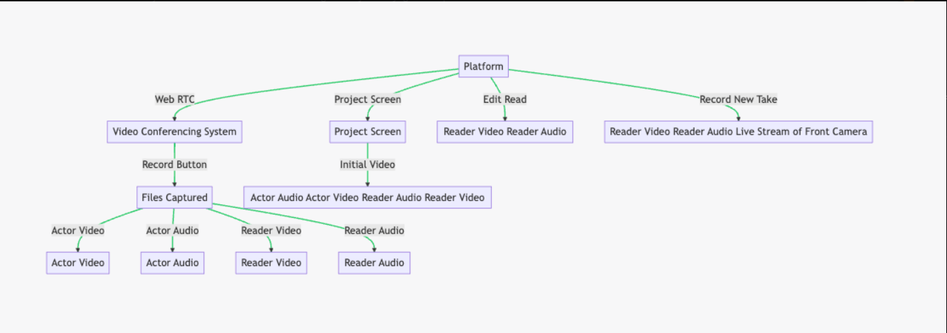

## 2) Backend Web API & Database

- .Net Core Web API + C#

- MSSQL Server

# 2. Platform Infrastructure

MSSQL Server

Conferencing Room Server

Backend WebAPI

Actor

Reader

Tape Bucket

([video-client-upload-123456798](https://s3.console.aws.amazon.com/s3/buckets/video-client-upload-123456798?region=us-east-2))

Photo Bucket

([perfectself-avatar-bucket](https://s3.console.aws.amazon.com/s3/buckets/perfectself-avatar-bucket?region=us-east-2))

Thumbnails Bucket

([perfectself-avatar-bucket](https://s3.console.aws.amazon.com/s3/buckets/perfectself-avatar-bucket?region=us-east-2))

Sctript Bucket

([perfectself-script-bucket](https://s3.console.aws.amazon.com/s3/buckets/perfectself-script-bucket?region=us-east-2))



Conferencing

AWS Lambda

# 3. Microservice with AWS

## 1) Upload and download recording result to/from S3 bucket.

- **Bucket Name**: **video-client-upload-123456798**

**- Video Thumbnail Bucket Name: video-thumbnail-bucket-123456789**

Thumbnails will be generate lambda function.

|  |  |
| --- | --- |
| **Lambda Function Name** | **Region** |
| thumbnail-generator | us-east-2 |

- **Tape key Format**

**Video recording object key**: {Date}/{RoomID}/{TapeID}/{UserName}.mp4

**Audio recording object key**: {Date}/{RoomID}/{TapeID}/{UserName}.m4a

**Example:**

1. 2023-06-01/9015597c-6137-4593-8eb1-87deaf439587/1719015/Marcelino.mp4
2. 2023-06-01/9015597c-6137-4593-8eb1-87deaf439587/1719015/Marcelino.m4a

**- Detail comment.**

a) RoomID: GUID to generate by Server.

b) TapeID: Time string when record conferencing. That is, hhMMssf

c) UserName: User name to own this tape.

# 4. Conferencing Protocol.

(*Will be more detail in the future*)